Contemplative Noonday Prayer
and Scriptural Reflection|
April 8, 2026
St. Columba’s Episcopal Church
Inverness, CA

St. Madrun, Widow

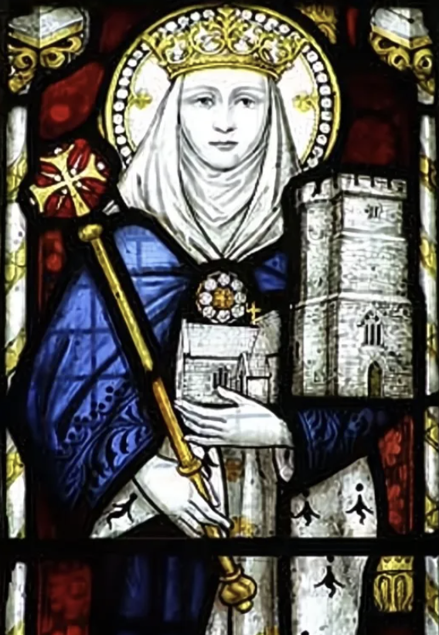

4th Century

Please respond with your microphone set on mute.
Mother Teri: O God, make speed to save us.
Assistant: O Lord, make haste to help us.
+Glory to You O Eternal Source, Divine Savior, and Holy Spirit:
As it was in the beginning, is now, and will be forever. Amen.

The Collect, Mother Teri:
O God our refuge; inspire us and lend courage to those who seek to provide true refuge – shelter, safety, comfort – for your children in war-torn areas throughout the world. In your name we pray, Amen. (Noonday service 9/25/24)

Psalm: Mother Teri will read to the asterix; please join by repeating the lines after on mute.

Psalm 118:14-24

New Revised Standard Version, Anglicised
The Lord is my strength and my might;
he has become my salvation.
There are glad songs of victory in the tents of the righteous:
‘The right hand of the Lord does valiantly;
the right hand of the Lord is exalted;
the right hand of the Lord does valiantly.’
I shall not die, but I shall live,
and recount the deeds of the Lord.
The Lord has punished me severely,
but he did not give me over to death.
Open to me the gates of righteousness,
that I may enter through them
and give thanks to the Lord.
This is the gate of the Lord;
the righteous shall enter through it.
I thank you that you have answered me
and have become my salvation.
The stone that the builders rejected
has become the chief cornerstone.
This is the Lord’s doing;
it is marvellous in our eyes.
This is the day that the Lord has made;
let us rejoice and be glad in it.
Assistant: ​​+ Glory to You O Eternal Source, Divine Savior, and Holy Spirit:
Mother Teri: ​As it was in the beginning is now and will be forever. Amen

Assistant:

A reading from the Holy Gospel of St. Matthew 28:1-10
At supper with his friends, Jesus was troubled in spirit, and declared, "Very truly, I tell you, one of you will betray me." The disciples looked at one another, uncertain of whom he was speaking. One of his disciples-- the one whom Jesus loved-- was reclining next to him; Simon Peter therefore motioned to him to ask Jesus of whom he was speaking. So while reclining next to Jesus, he asked him, "Lord, who is it?" Jesus answered, "It is the one to whom I give this piece of bread when I have dipped it in the dish." So when he had dipped the piece of bread, he gave it to Judas son of Simon Iscariot. After he received the piece of bread, Satan entered into him. Jesus said to him, "Do quickly what you are going to do." Now no one at the table knew why he said this to him. Some thought that, because Judas had the common purse, Jesus was telling him, "Buy what we need for the festival"; or, that he should give something to the poor. So, after receiving the piece of bread, he immediately went out. And it was night.
When he had gone out, Jesus said, "Now the Son of Man has been glorified, and God has been glorified in him. If God has been glorified in him, God will also glorify him in himself and will glorify him at once."

Mother Teri Hear what the Spirit is saying.
Assistant: Thanks be to God.
Celtic Contemplation
Please sit comfortably and close your eyes for 15 minutes of silent meditation.​ ​For today’s reflection:
Be O Lord,
a guiding star above me,
a smooth path below me,
a kindly shepherd behind me
and a bright flame before me;
-St. Columba
< Meditation: 15 minutes >

Please follow along and chant the Kyrie with us while on mute. We will chant 3x through.

Mother Teri / Assistant

Kyrie Eleison (Kyrie Eleison)
Christe Eleison (Christe Eleison)
Kyrie (Kyrie), Christe (Christe)
Eleison (Eleison)

Mother Teri: Please join now in praying as Jesus taught...
Our Father, who art in heaven, hallowed be thy name. Thy kingdom come, Thy will be done, on earth as it is in heaven. Give us this day our daily bread, and forgive us our trespasses as we forgive those who trespass against us. Lead us not into temptation, but deliver us from evil. For thine is the kingdom and the power and the glory, for ever and ever. Amen.
Mother Teri ​: Lord, hear our prayer;
Assistant: And let our cry come to you. ​
Mother Teri:
Let us pray, using words from the Ita Compline
Search me, O God, and know my heart.
Test me and know my thoughts.
Keep Your people, Lord, in the arms of Your embrace.
Shelter them under Your wings.
Mother Teri: For whom and what else do we pray?

Please offer your intercessions here, aloud or silently.
Prayers given aloud are followed with:

Mother Teri: We pray to the Lord
Assistant: Lord, hear our prayer
Continuing after personal intercessions with...
Be their light in darkness.
Be their hope in distress.
Be their calm in anxiety.
Be strength in their weakness.
Be their comfort in pain.
Be their song in the night.
Let us bless the Lord.
Thanks be to God.

Please remain with us for a word on today’s saint and discussion on today’s scriptural reading.

St. Madrun, Widow
(Materiana)

5th century; a second feast is celebrated on October 19. According to a dubious "vita," Madrun was the daughter of Vortimer and wife of Ynyr Gwent, ruler of the area around Caerwent (Monmouthshire). Following the battle described by Nennius in which Vortigern was killed, Madrun fled with the youngest of her three children, Ceidio, first to Carn Fadryn and then to Cornwall. She was either Welsh or Cornish, and churches are dedicated to her honour in Tintagel and Minster (near Boscastle), where she was buried.

Another Life:
The church perched on the cliffs above Tintagel, with its fine Norman windows and lichen covered gravestones, buttressed against the Atlantic gales, is dedicated to St. Materiana. The village, lying below in a more sheltered spot, now makes a living from visitors to the headland, with its romantic remains of castle and monastery. The headland is Tintagel, the village, in fact, Trevenna, and the church an outlying Chapel of the old Priory at Minster, in which was the shrine of St. Materiana. The Austin Friars have gone, and so has the shrine, but the Priory Church continues as the mother church of Boscastle.
Materiana was more a refugee than a missionary, but that has been one of the ways the faith has been spread since the earliest days of the Gospel. We read in the Acts of the Apostles, after the martyrdom of S. Stephen: Therefore they that were scattered abroad went everywhere preaching the word, and that appears to be the case with St. Materiana. She was the daughter of Vortimer, marrying Ynyr Gwent, who ruled that part of Monmonthshire east of the Usk river and in Wales was called Madrum or Madryn. Her sister Anna married Cynyr and was the mother of St. Non.
Ynyr was responsible for establishing St. Tathan and his school at Caerwent, and the holy man became the family's spiritual director. No doubt Madrum learnt a great deal from St. Tathan but her daughter Tegiwg grew up a self willed young lady and ran off with a handsome young carpenter. The carpenter, however, deserted her, and she was found dead by St. Beuno's shepherds. The good bishop resuscitated her, and she then was persuaded to enter a convent.
Soon after this, the native Britons rose in revolt against the Irish landowners, and Ynyr fled with his wife Madrun to the fortress of Vortigern in Carnarvenshire, in a valley beneath Snowdon. The rebels besieged and set fire to the castle, Ynyr was killed and Madrun escaped with her son Ceidio in her arms and made a new home in Cornwall. In Wales, Trawsfynydd, and in Cornwall, both Minster and Tintagel claim her as their foundress. https://celticsaints.org/2026/0409b.html

---Scriptural Study---

Psalm 118:14-24

New Revised Standard Version, Anglicised
The Lord is my strength and my might;
he has become my salvation.
There are glad songs of victory in the tents of the righteous:
‘The right hand of the Lord does valiantly;
the right hand of the Lord is exalted;
the right hand of the Lord does valiantly.’
I shall not die, but I shall live,
and recount the deeds of the Lord.
The Lord has punished me severely,
but he did not give me over to death.
Open to me the gates of righteousness,
that I may enter through them
and give thanks to the Lord.
This is the gate of the Lord;
the righteous shall enter through it.
I thank you that you have answered me
and have become my salvation.
The stone that the builders rejected
has become the chief cornerstone.
This is the Lord’s doing;
it is marvellous in our eyes.
This is the day that the Lord has made;
let us rejoice and be glad in it.

Matthew 28:1-10

New Revised Standard Version, Anglicised
After the sabbath, as the first day of the week was dawning, Mary Magdalene and the other Mary went to see the tomb. And suddenly there was a great earthquake; for an angel of the Lord, descending from heaven, came and rolled back the stone and sat on it. His appearance was like lightning, and his clothing white as snow. For fear of him the guards shook and became like dead men. But the angel said to the women, ‘Do not be afraid; I know that you are looking for Jesus who was crucified. He is not here; for he has been raised, as he said. Come, see the place where he lay. Then go quickly and tell his disciples, “He has been raised from the dead, and indeed he is going ahead of you to Galilee; there you will see him.” This is my message for you.’ So they left the tomb quickly with fear and great joy, and ran to tell his disciples. Suddenly Jesus met them and said, ‘Greetings!’ And they came to him, took hold of his feet, and worshipped him. Then Jesus said to them, ‘Do not be afraid; go and tell my brothers to go to Galilee; there they will see me.’

excerpted from the Ita Compline, Northumbria Community.

