Contemplative Noonday Prayer
& Scriptural Reflection April 24, 2024
___________________
St. Columba’s Episcopal Church, Inverness, CA

St. Maughold of Man, Bishop

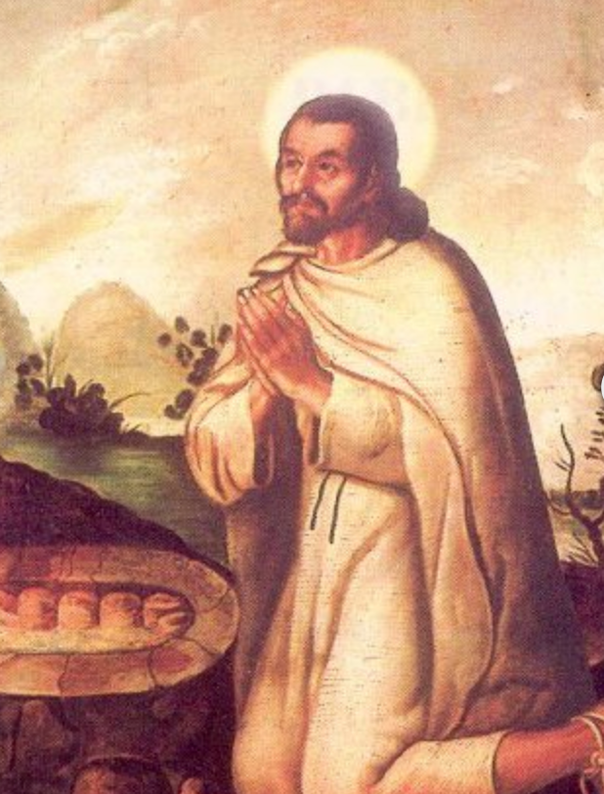
Died c. 488

We will need 3 readers for today…
Reader 1 will read the opening responses and collect,
Reader 2 the psalm responses and
Reader 3, responses for intercessory prayers and Eta Compline.

(Reader 1 please unmute)
All: Please respond with your microphone set on mute.

Mother Teri: O God, make speed to save us.
Reader 1: O Lord, make haste to help us.

+ Glory to You O Eternal Source,
Divine Savior, and Holy Spirit:

As it was in the beginning is now
and will be forever. Amen

Reader 1: The Collect

O God of abundance, who alone knows the number of our days, we ask for patience, trust, and understanding, so that we can be fully present in the now of your beloved community; in your name we pray. Amen.
(3/21/22), Noonday Prayer Group)

(Reader 2 please unmute)

Psalm 122 NRSV
Please join by repeating lines in bold italics at home on mute.

Deacon Ari: I was glad when they said to me,
‘Let us go to the house of the Lord!’
Reader 2 & all: Our feet are standing
within your gates, O Jerusalem.
Jerusalem—built as a city
that is bound firmly together.
To it the tribes go up,
the tribes of the Lord,
as was decreed for Israel,
to give thanks to the name of the Lord.
For there the thrones for judgement were set up,
the thrones of the house of David.
Pray for the peace of Jerusalem:
‘May they prosper who love you.
Peace be within your walls,
and security within your towers.’
For the sake of my relatives and friends
I will say, ‘Peace be within you.’
For the sake of the house of the Lord our God,
I will seek your good.
Deacon Ari: + Glory to You O Eternal Source,
Divine Savior, and Holy Spirit:

Reader 2 & All: As it was in the beginning is now
and will be forever. Amen

Deacon Ari:

A reading from the Gospel of Luke 12:4-12 NRSV
‘I tell you, my friends, do not fear those who kill the body, and after that can do nothing more. But I will warn you whom to fear: fear him who, after he has killed, has authority to cast into hell. Yes, I tell you, fear him! Are not five sparrows sold for two pennies? Yet not one of them is forgotten in God’s sight. But even the hairs of your head are all counted. Do not be afraid; you are of more value than many sparrows.
‘And I tell you, everyone who acknowledges me before others, the Son of Man also will acknowledge before the angels of God; but whoever denies me before others will be denied before the angels of God. And everyone who speaks a word against the Son of Man will be forgiven; but whoever blasphemes against the Holy Spirit will not be forgiven. When they bring you before the synagogues, the rulers, and the authorities, do not worry about how you are to defend yourselves or what you are to say; for the Holy Spirit will teach you at that very hour what you ought to say.’

Deacon Ari Hear what the Spirit is saying.
Reader 2 & All: Thanks be to God.

Celtic Contemplation: 15 minutes

“Do not be afraid; you are of
more value than many sparrows.”

Please follow along and chant the Kyrie with us while on mute. We will chant 3x through.

Deacon Ari / Mother Teri & All

Kyrie Eleison (Kyrie Eleison)
Christe Eleison (Christe Eleison)
Kyrie (Kyrie), Christe (Christe)
Eleison (Eleison)

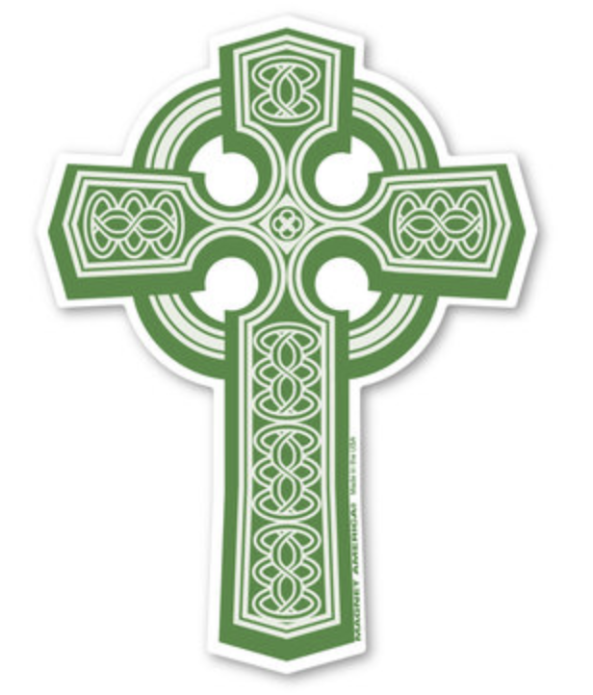

Mother Teri: Please join now in praying as Jesus taught…
(ALL) Our Father in heaven,
hallowed be your Name, Your kingdom come, Your will be done, on earth as in heaven. Give us today our daily bread. Forgive us our sins as we forgive those who sin against us. Save us from the time of trial, and deliver us from evil. For the kingdom, the power, and the glory are yours, now and for ever. Amen.

Deacon Ari: Lord, hear our prayer;
Reader 3 & All: And let our cry come to you.

Let us pray, using words from the Ita Compline
Search me, O God, and know my heart.
Test me and know my thoughts.
Keep Your people, Lord, in the arms of Your embrace. Shelter them under Your wings.
Deacon Ari: For whom and what else do we pray?

Please offer your intercessions here, aloud or silently.
Prayers given aloud are followed with:

Deacon Ari: We pray to the Lord
Reader 3 & All: Lord, hear our prayer
Continuing after personal intercessions with...
Be their light in darkness.
Be their hope in distress.
Be their calm in anxiety.
Be strength in their weakness.
Be their comfort in pain.
Be their song in the night.
Let us bless the Lord.
Thanks be to God.
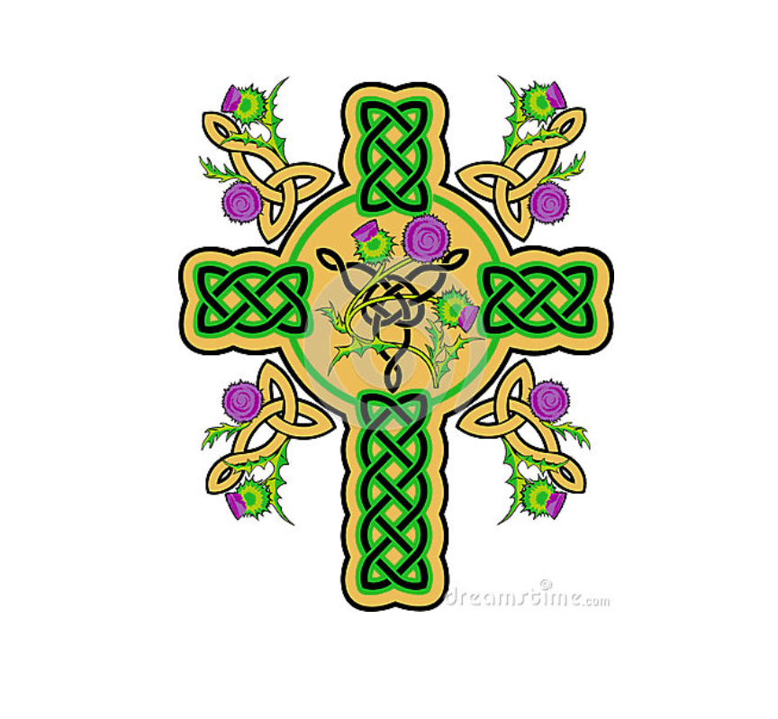

Please remain for discussion
on today’s topic and scriptural reading.

St. Maughold of Man, Bishop

Died c. 488. Saint Maughold was an Irish prince and reputedly a captain of robbers who was converted by Patrick. Upon his conversion, he became a new man by putting on the spirit of Christ. One version of the legend says that Patrick told him to put to sea in a coracle without oars as a penance for his evil deeds. Another says that he set sail in order to avoid the temptations of the world. In both stories, he retired to the Isle of Man (Eubonia) off the coast of Lancashire, England.
Earlier Patrick had sent his nephew, Saint Germanus, as bishop to plant the Church on the island. Germanus was succeeded by Saints Romulus and Conindrus during whose time Maughold arrived on the island and began to live an austere, penitential life in the mountainous area now named after him Saint Maughold. After their deaths, Maughold was unanimously chosen as bishop by the Manks.
In one of the 18 parish churchyards on the island can be found Saint Maughold's well. The very clear water of the well is received in a large stone coffin. Those seeking cures of various ailments, particularly poisoning, are seated in the saint's chair just above the well and given a glass of well-water to drink. Maughold's shrine was here until the relics were scattered during the Reformation.
https://celticsaints.org/2022/0425c.html

Scriptural Study

Psalm 122

I was glad when they said to me,
‘Let us go to the house of the Lord!’
Our feet are standing
within your gates, O Jerusalem.
Jerusalem—built as a city
that is bound firmly together.
To it the tribes go up,
the tribes of the Lord,
as was decreed for Israel,
to give thanks to the name of the Lord.
For there the thrones for judgement were set up,
the thrones of the house of David.
Pray for the peace of Jerusalem:
‘May they prosper who love you.
Peace be within your walls,
and security within your towers.’
For the sake of my relatives and friends
I will say, ‘Peace be within you.’
For the sake of the house of the Lord our God,
I will seek your good.

Luke 12:4-12
‘I tell you, my friends, do not fear those who kill the body, and after that can do nothing more. But I will warn you whom to fear: fear him who, after he has killed, has authority to cast into hell. Yes, I tell you, fear him! Are not five sparrows sold for two pennies? Yet not one of them is forgotten in God’s sight. But even the hairs of your head are all counted. Do not be afraid; you are of more value than many sparrows.
‘And I tell you, everyone who acknowledges me before others, the Son of Man also will acknowledge before the angels of God; but whoever denies me before others will be denied before the angels of God. And everyone who speaks a word against the Son of Man will be forgiven; but whoever blasphemes against the Holy Spirit will not be forgiven. When they bring you before the synagogues, the rulers, and the authorities, do not worry about how you are to defend yourselves or what you are to say; for the Holy Spirit will teach you at that very hour what you ought to say.’

excerpted from the Ita Compline, Northumbria Community.

