Contemplative Noonday Prayer
& Scriptural Reflection May 13, 2026
___________________
St. Columba’s Episcopal Church, Inverness, CA

Saint John of Beverley

Bishop of York

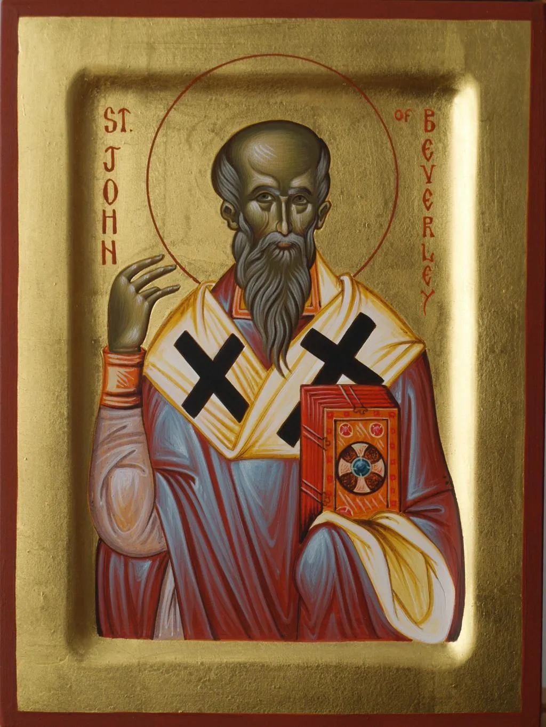
Died c.721

Mother Teri: O God, make speed to save us.
Reader 1: O Lord, make haste to help us.

+ Glory to You O Eternal Source,
Divine Savior, and Holy Spirit:

As it was in the beginning is now
and will be forever. Amen

Reader 1: The Collect
O God our Shepherd, we ask your comforting presence and strength so that we may set aside striving and worry to relax in your green pastures with still, plentiful water; in your name we pray, Amen.
(5/04/22), Noonday Prayer Group)

Psalm 100 NRSV

Please join by repeating lines in bold italics at home on mute.

Mother Teri: Make a joyful noise to the Lord, all the earth.

Assistant: Worship the Lord with gladness;
come into his presence with singing.

Know that the Lord is God.
It is he that made us, and we are his;
we are his people, and the sheep of his pasture.
Enter his gates with thanksgiving,
and his courts with praise.
Give thanks to him, bless his name.
For the Lord is good;
his steadfast love endures for ever,
and his faithfulness to all generations.
Mother Teri: + Glory to You O Eternal Source,
Divine Savior, and Holy Spirit:

Assistant: As it was in the beginning is now
and will be forever. Amen

Mother Teri:

A reading from the Gospel of John 10:31-42 NRSV
The Jews took up stones again to stone him. Jesus replied, ‘I have shown you many good works from the Father. For which of these are you going to stone me?’ The Jews answered, ‘It is not for a good work that we are going to stone you, but for blasphemy, because you, though only a human being, are making yourself God.’ Jesus answered, ‘Is it not written in your law, “I said, you are gods”? If those to whom the word of God came were called “gods”—and the scripture cannot be annulled— can you say that the one whom the Father has sanctified and sent into the world is blaspheming because I said, “I am God’s Son”? If I am not doing the works of my Father, then do not believe me. But if I do them, even though you do not believe me, believe the works, so that you may know and understand that the Father is in me and I am in the Father.’ Then they tried to arrest him again, but he escaped from their hands.
He went away again across the Jordan to the place where John had been baptizing earlier, and he remained there. Many came to him, and they were saying, ‘John performed no sign, but everything that John said about this man was true.’ And many believed in him there.

Mother Teri: Hear what the Spirit is saying.
Assistant: Thanks be to God.
Celtic Contemplation: 15 minutes

“God's eyes to watch over me;
God's ear to hear me”

-Brigid of Kildare

Please follow along and chant the Kyrie with us while on mute. We will chant 3x through.

Assistant / Mother Teri & All

Kyrie Eleison (Kyrie Eleison)
Christe Eleison (Christe Eleison)
Kyrie (Kyrie), Christe (Christe)
Eleison (Eleison)
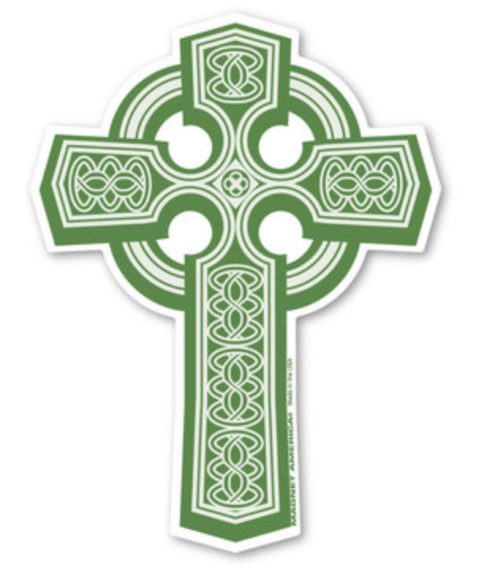
Mother Teri: Please join now in praying as Jesus taught…
(ALL) Our Father in heaven,
hallowed be your Name, Your kingdom come, Your will be done, on earth as in heaven. Give us today our daily bread. Forgive us our sins as we forgive those who sin against us. Save us from the time of trial, and deliver us from evil. For the kingdom, the power, and the glory are yours, now and for ever. Amen.

Mother Teri: Lord, hear our prayer;
Assistant: And let our cry come to you.

Let us pray, using words from the Ita Compline
Search me, O God, and know my heart.
Test me and know my thoughts.
Keep Your people, Lord, in the arms of Your embrace. Shelter them under Your wings.
Mother Teri: For whom and what else do we pray?

Please offer your intercessions here, aloud or silently.
Prayers given aloud are followed with:

Mother Teri: We pray to the Lord
Assistant: Lord, hear our prayer
Continuing after personal intercessions with...
Be their light in darkness.
Be their hope in distress.
Be their calm in anxiety.
Be strength in their weakness.
Be their comfort in pain.
Be their song in the night.

Let us bless the Lord.
Thanks be to God.

Please remain for discussion
on today’s topic and scriptural reading

John of Beverley

On this day we commemorate our holy father John of Beverley, bishop of Hexham and York, wonderworker of the Northumbrian lands.
This blessed hierarch was born of noble parents at Harpham in the East Riding of Yorkshire, within the ancient kingdom of Deira. From his youth he was dedicated to the service of God and was instructed in the monastic life at Whitby under the guidance of the holy abbess Hilda of Whitby. There he advanced in sacred learning, purity of life, and understanding of the Holy Scriptures, becoming renowned for wisdom in preaching and gentleness toward all.
In the year 687 he was consecrated bishop of Hexham by Theodore of Tarsus, and in 705 was raised to the throne of York, the chief ecclesiastical dignity of the Northumbrian realm. As hierarch he was diligent in visitation, merciful to the poor, and deeply concerned for the formation of clergy and students whom he instructed under his personal care.
Among those nurtured by his fatherly guidance was the Venerable Bede the Venerable, whom the saint ordained both deacon and priest. Through Bede’s writings the holy life and miracles of John have been preserved for later generations, together with the memory of his pastoral labours and holiness.
The saint founded a monastery in Deira Wood, in the place now called Beverley, then surrounded by oak woodland, springs, and waters. There he later withdrew after resigning his episcopal office, embracing stillness and prayer in preparation for his repose. He departed unto the Lord on the seventh day of May in the year 721.
Even during his earthly life the saint was renowned as a healer and wonderworker, and after his repose many miracles were wrought through his intercessions. Pilgrims came in great number to his tomb seeking healing, consolation, repentance, and deliverance from affliction. Thus Beverley prospered as a place sanctified by the presence and memory of the saint.
The holy John became especially associated with wells and springs. At Harpham, near the place of his birth, a spring long honoured by the people came to bear his name, and many healings were attributed to its waters. Tradition relates that the saint blessed the spring, and that through his prayers those who drank or washed there received relief from sicknesses and infirmities.
Another ancient well was preserved within Beverley Minster itself, near the high altar and sanctuary. Because of the sanctity attached to the waters and the miracles associated with the saint, the church was built so as to enclose and honour the well. Even now this hidden spring remains beneath the Minster, bearing witness to the ancient reverence shown toward the holy places connected with the saint.
Thus the holy hierarch sanctified not only the people entrusted to him, but also the land and waters of Northumbria, turning places once associated with ancient pagan reverence toward the worship of the Holy Trinity. For the Church in Britain did not reject creation, but offered it back to God in thanksgiving, blessing wells, springs, groves, and rivers, and making them signs of divine grace and healing.
Kings and rulers also sought the prayers of Saint John. His banner was carried into battle by princes of England, and many attributed victories and deliverance to his intercessions. Henry V especially honoured the saint after the victory at Agincourt, fought upon the feast of the translation of his relics, and ordered his feast to be celebrated throughout the realm.
Though his shrine suffered destruction during the upheavals of the Reformation, his memory has never perished. His relics remain honoured at Beverley Minster, where pilgrims still come in prayer. Around his feast the faithful process to Harpham Well with hymns and flowers, preserving the ancient devotion shown to the saint through many centuries.
Even in recent years, Orthodox faithful, especially from the Russian tradition, have continued to honour the saint and gather water from the well within Beverley Minster, preserving the memory of his blessing upon the land and its waters.
Through the prayers of our holy father John, O Christ our God, have mercy upon us and save us. Amen.



Scriptural Study

Psalm 100 NRSV

Make a joyful noise to the Lord, all the earth.
Worship the Lord with gladness;
come into his presence with singing.

Know that the Lord is God.
It is he that made us, and we are his;
we are his people, and the sheep of his pasture.
Enter his gates with thanksgiving,
and his courts with praise.
Give thanks to him, bless his name.
For the Lord is good;
his steadfast love endures for ever,
and his faithfulness to all generations.

A reading from the Gospel of John 10:31-42 NRSV
The Jews took up stones again to stone him. Jesus replied, ‘I have shown you many good works from the Father. For which of these are you going to stone me?’ The Jews answered, ‘It is not for a good work that we are going to stone you, but for blasphemy, because you, though only a human being, are making yourself God.’ Jesus answered, ‘Is it not written in your law, “I said, you are gods”? If those to whom the word of God came were called “gods”—and the scripture cannot be annulled— can you say that the one whom the Father has sanctified and sent into the world is blaspheming because I said, “I am God’s Son”? If I am not doing the works of my Father, then do not believe me. But if I do them, even though you do not believe me, believe the works, so that you may know and understand that the Father is in me and I am in the Father.’ Then they tried to arrest him again, but he escaped from their hands.
He went away again across the Jordan to the place where John had been baptizing earlier, and he remained there. Many came to him, and they were saying, ‘John performed no sign, but everything that John said about this man was true.’ And many believed in him there.

excerpted from the Ita Compline, Northumbria Community.

